Who are NHS Lothian?
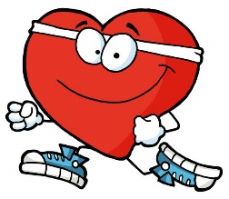 NHS Lothian are in charge of making sure that everyone who lives in our area have somebody to help them when they are sick. We do this by making sure there are hospitals, with doctors and nurses to look after you.

Why do we need to know things about you?
So we can help you when you’re not feeling well. We’ll ask you questions when you come to see us, or we might talk to some of the adults you know, like your mum and dad or your school. Sometimes we might need to give you medicine or take special pictures of your bones (it’s ok, it doesn’t hurt) and we keep this information in a book all about you called your Health Record. Some of the things you tell us will be written down on paper and some of them will be on a computer. In your record we keep:

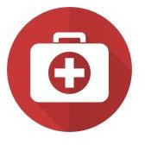
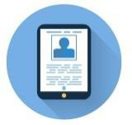 Your name, where you live and how old you are 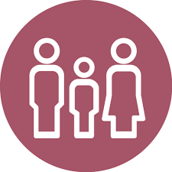 Who you live with and who looks after you
What care we have given you

Any photographs we take of you
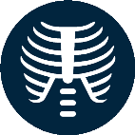 Results and scans of your body like X-Rays

We always keep your information private.
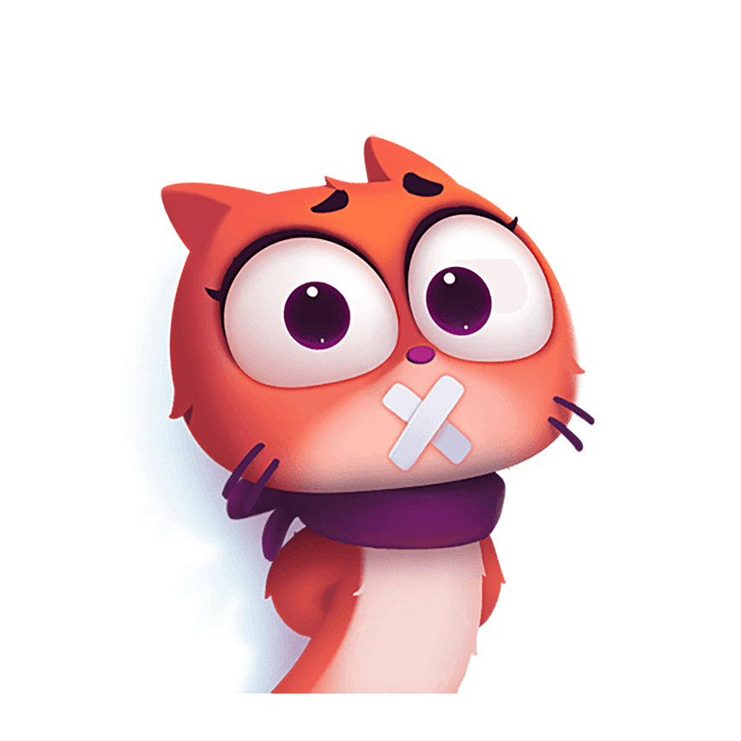The things you tell us are private, like a secret, and most of the time we are not allowed to tell anyone else unless you (or your mum and dad) say it’s ok first. If we do talk to anyone about you without your permission, it will only be when it’s really important; to look after you, make you better, or keep you safe. We might tell:

A police officer or somebody in your school who helps to keep you safe.

Other people who look after you, such as a doctor or nurse in a different hospital or at your GP Practice.

A researcher - Sometimes we need to use your information so doctors and nurses can learn new ways to make you and other people like you better – this is called research. When we do this, we remove things like your name, age and where you live so no one will know it’s about you.

The rules for looking after your records.

As we have private information about you, there are lots of rules that we need to obey - rules about how long we are allowed to keep your information, about how to stop anyone from taking it without permission, and about making sure that your record has information about you that is true. You are allowed to see all the information we have about you, and you can do this in different ways – you can ask your mum or dad to help you, or a different adult that you trust like your doctor or a teacher at school. There will usually be a form that you have to fill in, and you can get a copy of this form by asking somebody when you are in the hospital or by using the following contact details:

- Tel: 0131 242 3041 or 0131 242 3042
- Email: loth.sarteam@nhslothian.scot.nhs.uk

Do you have any questions that you want to ask us?
If you want to ask us any questions about your records, then we have a special person called a Data Protection Officer. Their job is to make sure that everybody follows the rules and keeps your information private, so if you think that somebody has broken the rules, or if you have any other questions about the information we hold on you, then you can contact them as follows:

- Tel: 0131 465 5444
- Email: loth.dpo@nhslothian.scot.nhs.uk

